For Sale - $165,000

Fully loaded cross-country cruiser… she empties the FBO everywhere she visits… ask the factory, they know the build and flying qualities of this airplane. Cruise 165-175 kias (180-190 ktas) in style and comfort. 1,000 nm range and 5 hour’s endurance.

Check out our album at our website https://www.velocityxl.com/album.php?albumid=19
YouTube Channel https://www.youtube.com/user/bferrell
XL – Extra Large body | 4 Leather Adjustable Seats with heaters and temper foam by Oregon Aero | All Glass Flight System by Grand Rapids Technology – GRT HX Dual Screen Dual AHRS/Magnetometers
Magnum Engines IO-540, 260 hours since overhaul, high compression – parallel valve but Dyno tested at Lycon at 316 HP | Garmin GTN-650 WAAS NAV Com  Artex G406 ELT | 3 Screen EFIS – 2 for Pilot (6.5”) and 1 for CoPilot (8.4”)  Dual Engine Controls
Fuel Sight Gauges and Capacitive Gauges | PS Engineering PS8000B 4 place Intercom/Audio Panel | Garmin SL-30 NAV/COM 2  ADS-B Compliant In and Out
XeVision Xenon HID Landing Light | B&C Starter | Mode S (Garmin GTX330) and ADS-B Traffic Display on EFIS
Back-Lighted Overhead Switch Panel | Aux Audio in for iPad/MP3 input in panel | ADS-B Weather Display on EFIS
VP-X Electronic Circuit Breaker System, integrated into EFIS | Front Seats feature in headrest DVD screens for rear seat passengers | Audible Warnings to Intercom
Approach Fast-Stack Instrument wiring system | 10 Disc DVD/CD player for in flight music or entertainment | Built-in CO Guardian Aero 455 Pulse Oximeter for high altitude flight
Radenna Sky-Radar D2 ADS-B Receiver | Standard Aviation ground power plug for jump start or battery charging | Trio Pro dual axis AutoPilot – Independent head, but can slave to the GTN-650 or EFIS, with AutoTrim
APRS tracking system on-board continuously transmit speed, location, altitude and heading via Ham Radio | Full backup instrumentation – Airspeed, Altimeter, Artificial Horizon, Tach, fuel level, Slip-Skid, Compass | Factory built fast-build wings and fuselage – straight and fast!
LightSpeed Engineering Plasma III Electronic Ignition | Heated Pitot tube for IFR | Whelen Nav/Strobe pack for night/IFR
Dual B&C Alternators with external field regulation and over-voltage protection (60A primary and 20 A on vacuum pump pad) | Leather Trimmed Interior with Embossed Velocity logo on back panel | MT Constant-Speed (hydraulic) Propeller  Billet aluminum nose wheel fork upgrade  Velocity factory Cleveland brake upgrade
Velocity factory toe brake upgrade | Velocity factory rain/weather cover with custom N44VF embroidery | Sky-3D GoPro camera mounts on each wing for in-flight video
14V Electric System

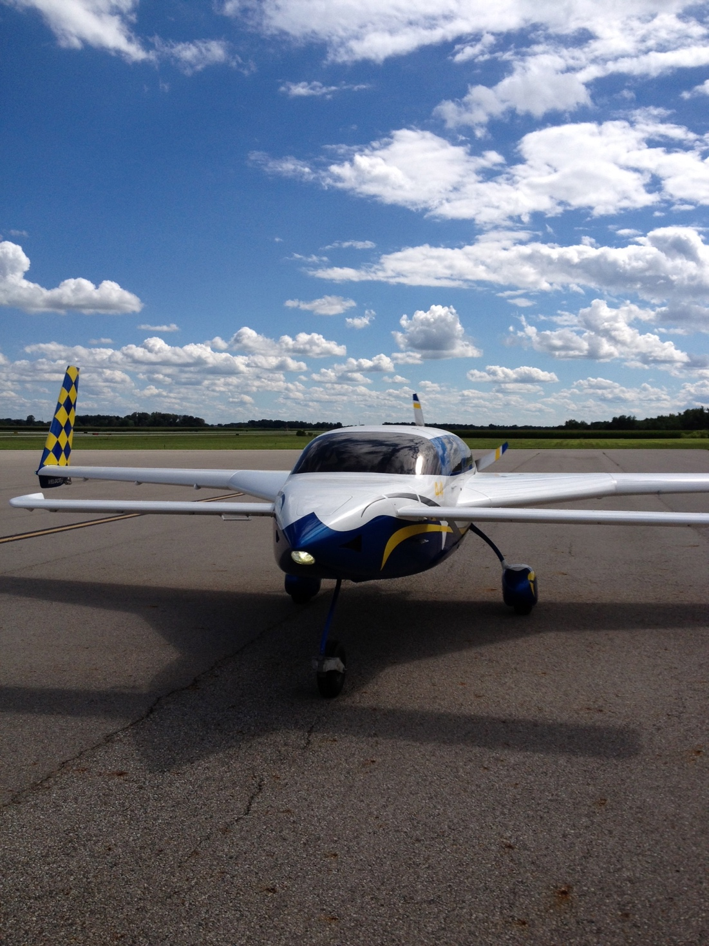

GRT Horizon HX EFIS Glass Panel

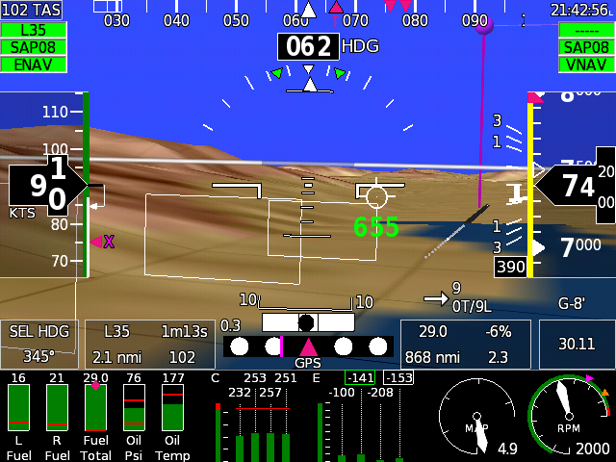  PFD with Synthetic terrain/runways and highway in the sky | 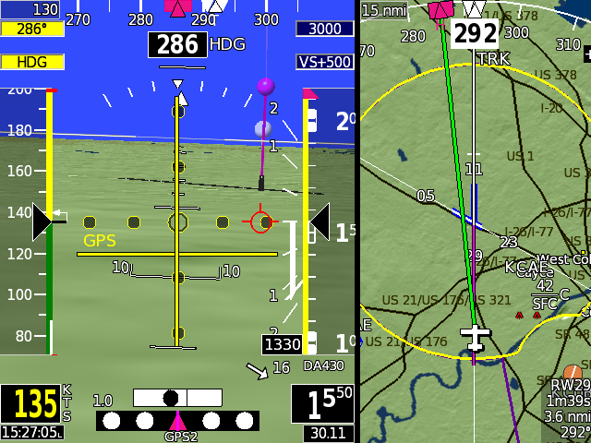  Screens can split PFD/Map and show glideslope/CDI | 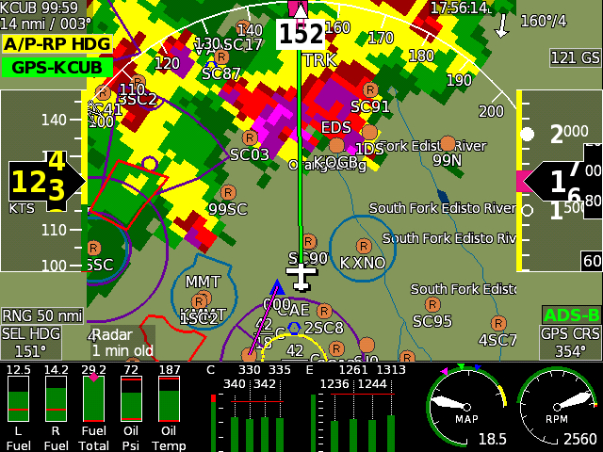  Full weather display
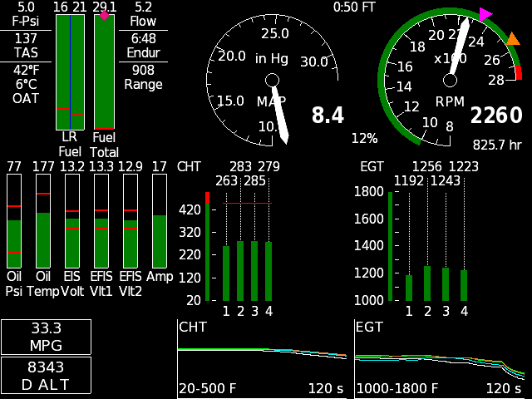  Example of Engine Display – CHT/EGT for all six cylinders | 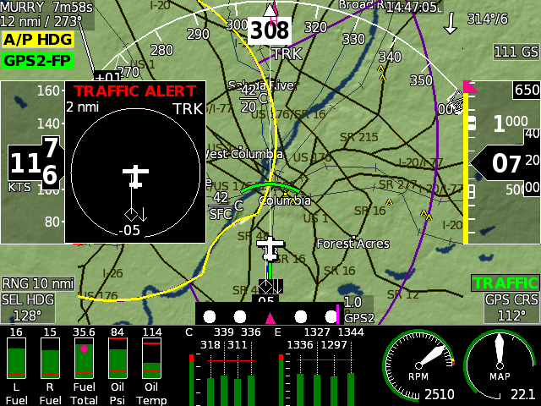  Mode S and ADS-B Traffic with Alerting | 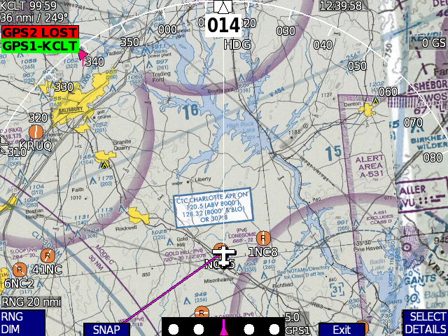  Moving map can display sectional, enroute charts, moving map with airspace, traffic, and weather
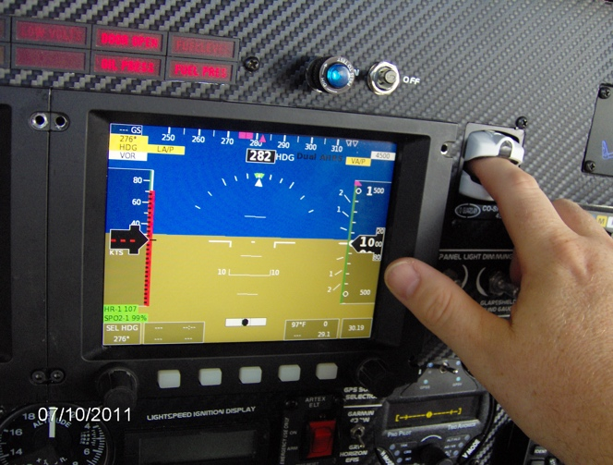  CO Guardian & Pulse Oximeter | 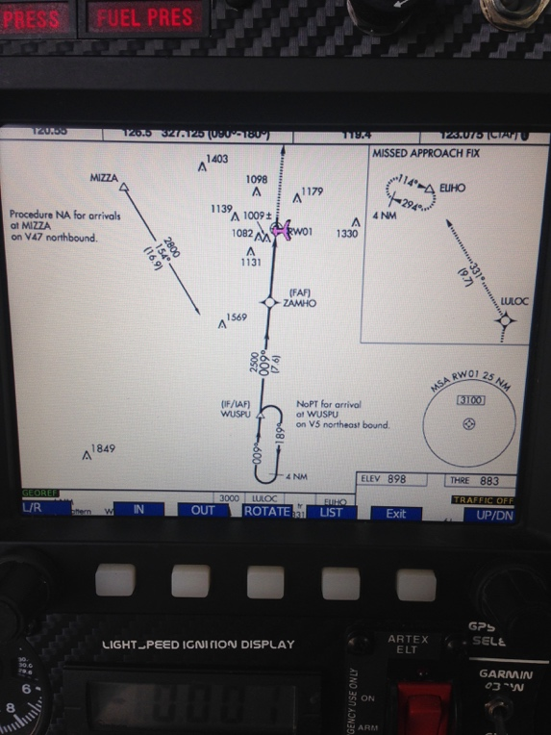
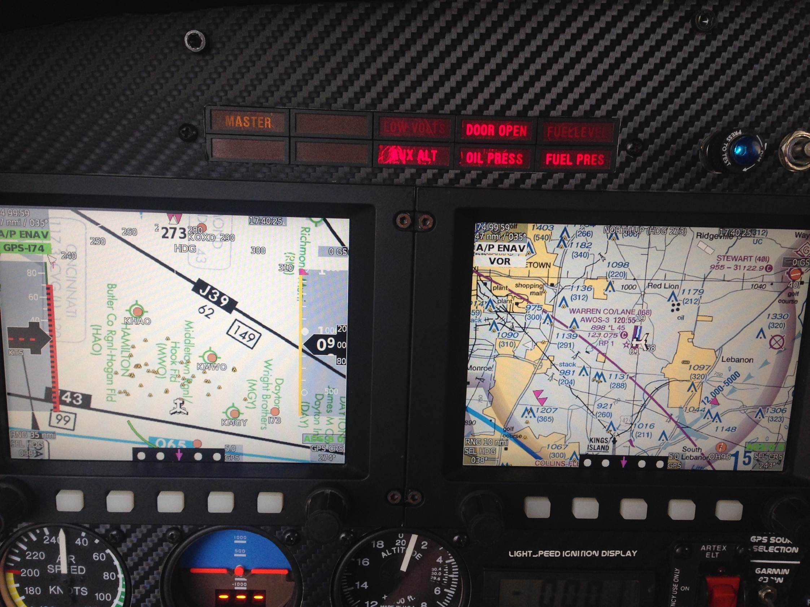
Other Features
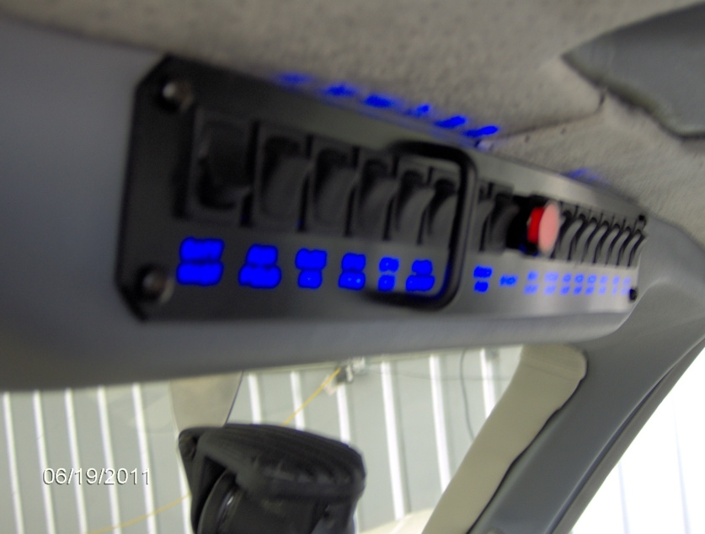  Back-Lighted Switch Panel | 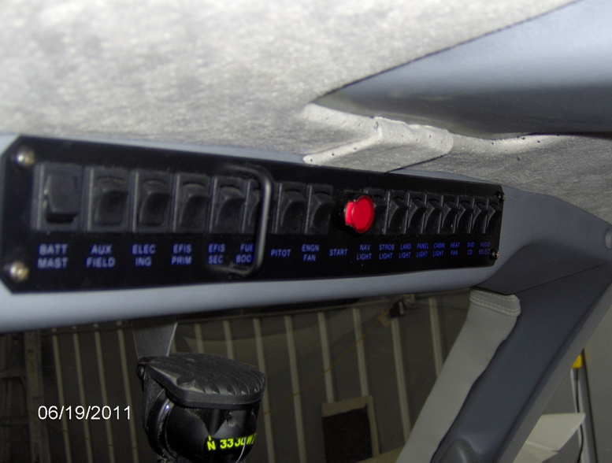  Back-Lighted Switch Panel | 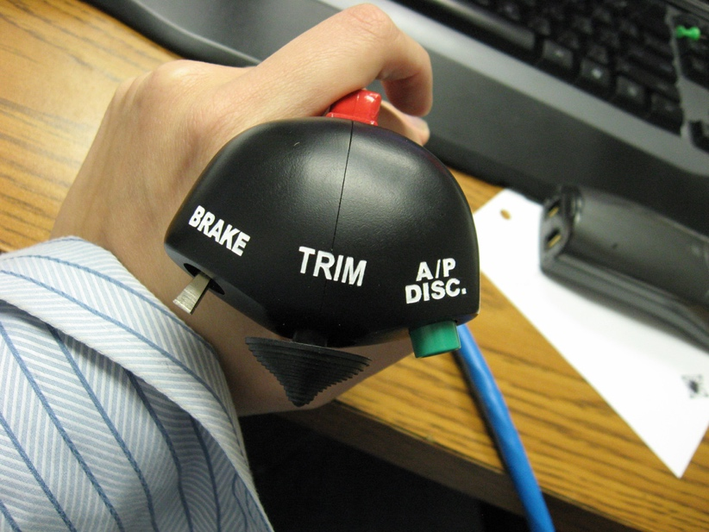  Engraved center stick
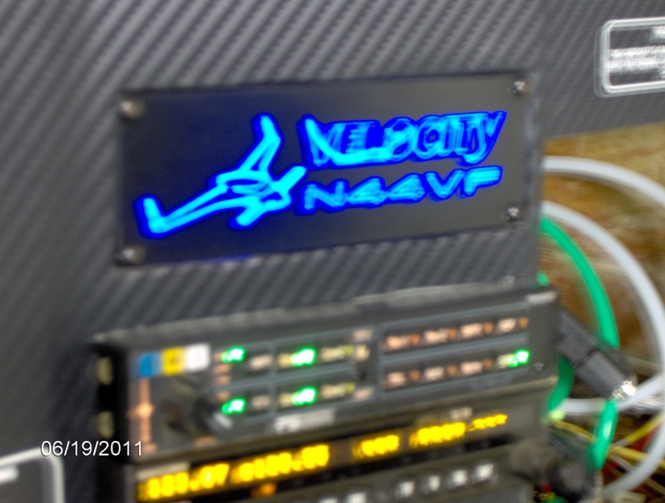  In-Panel lighted Velocity Logo | 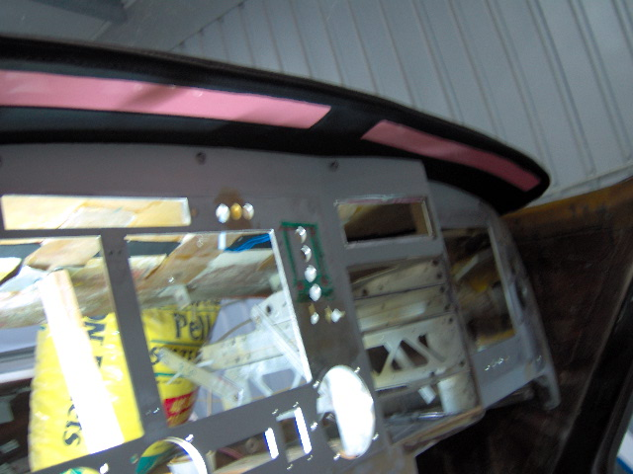  Electro-Illuminescent glare shield map lighting | 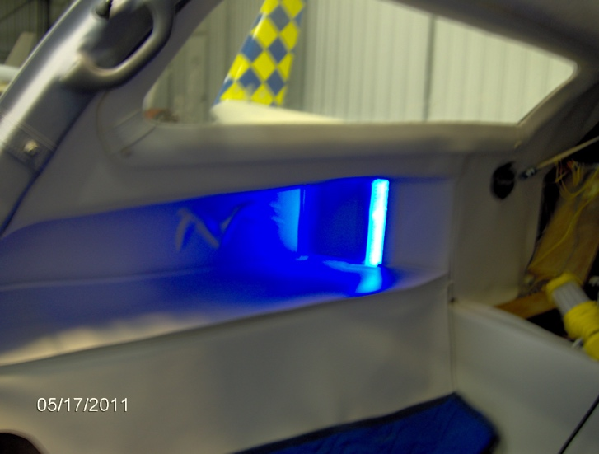  Lighted Fuel Site Gauges
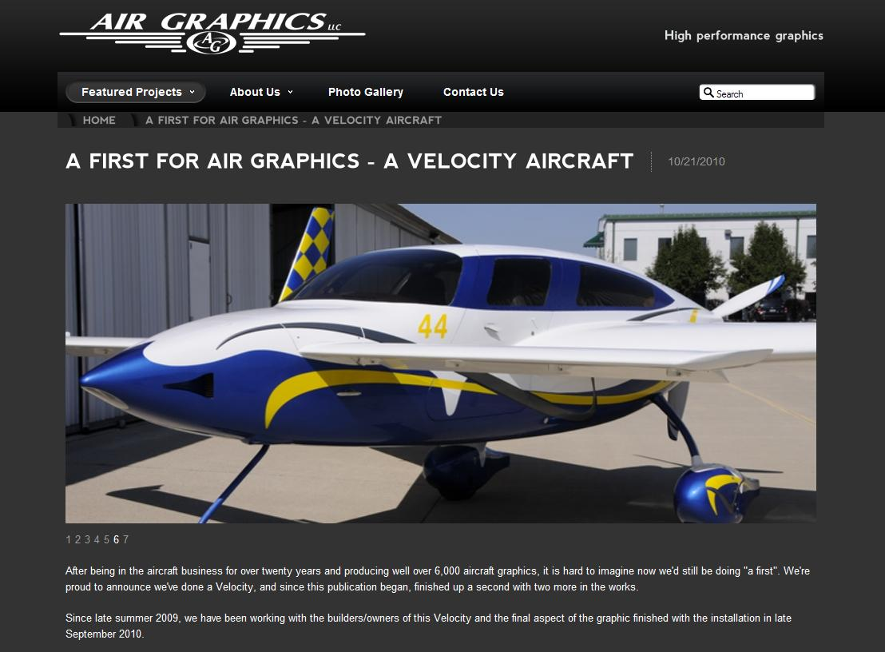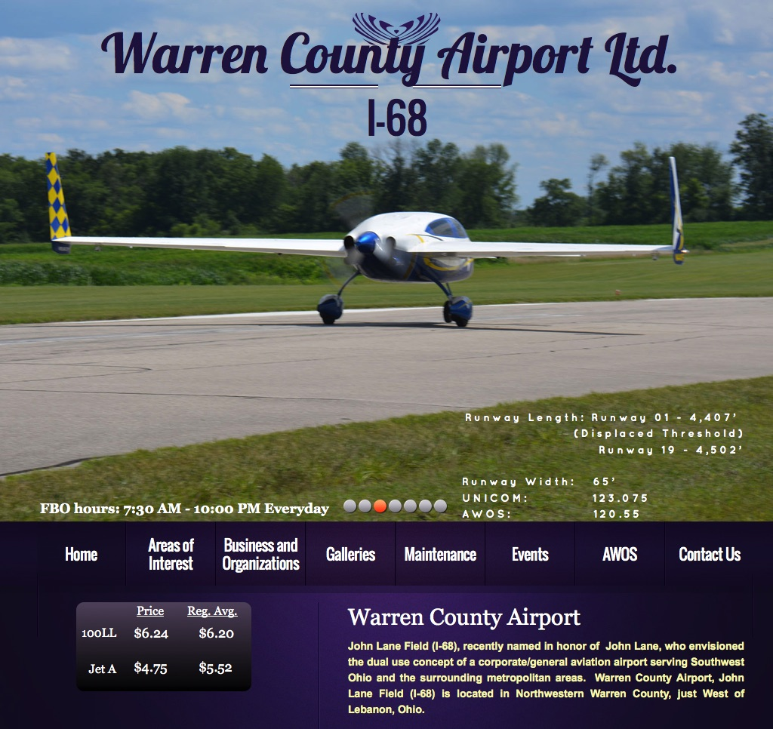

Featured by Air Graphics Featured by Warren County Airport

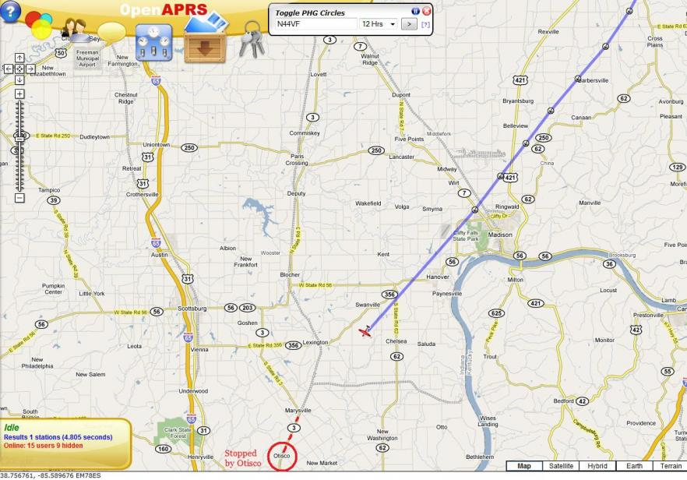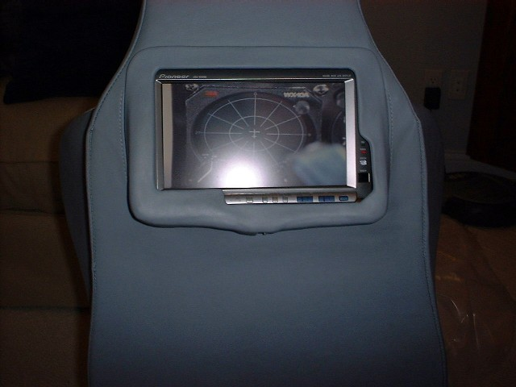
APRS Ham Radio Tracking DVD Screen
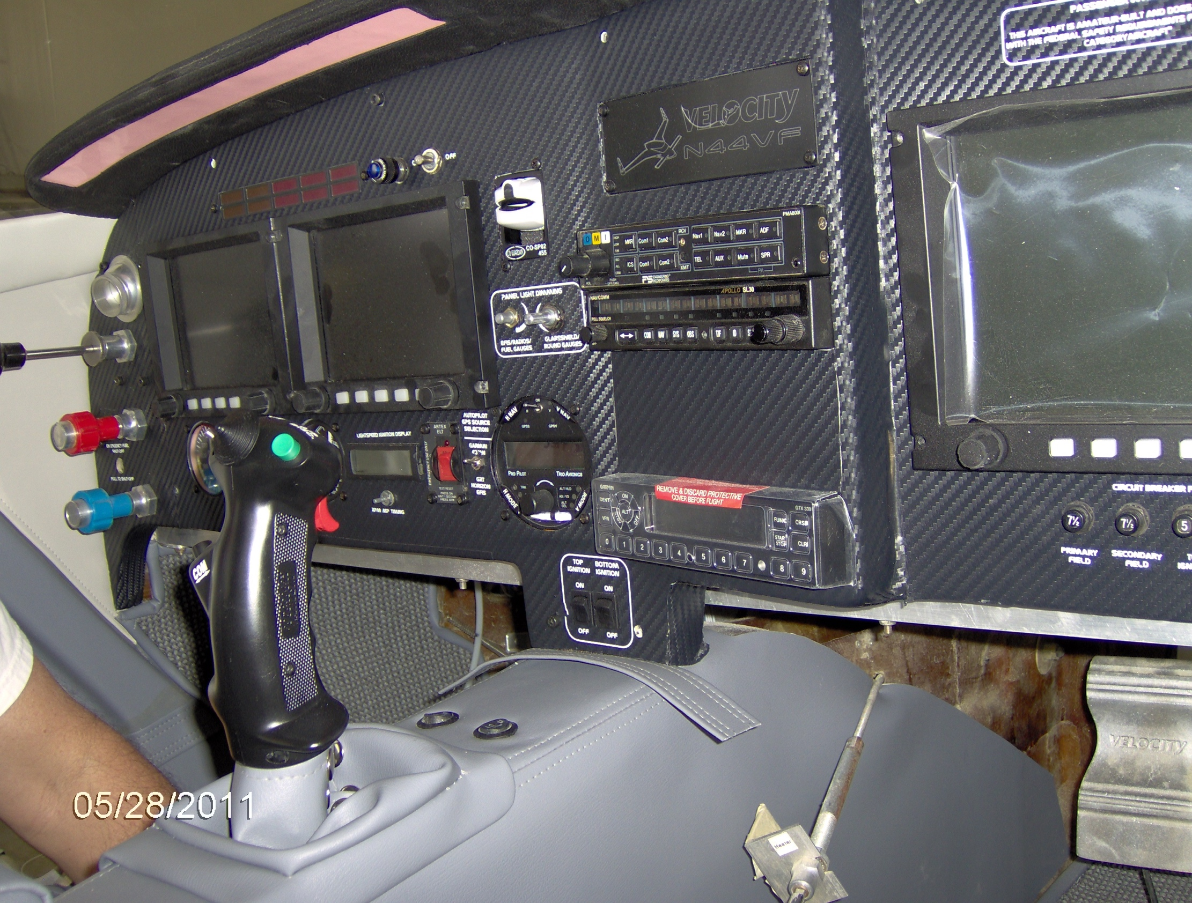

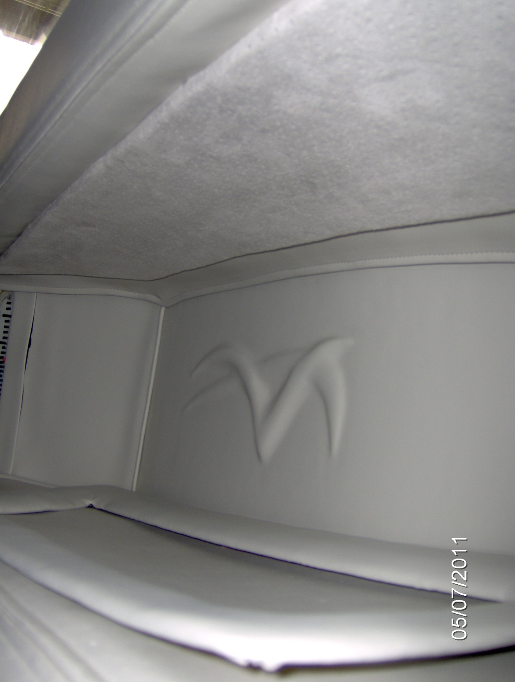 | 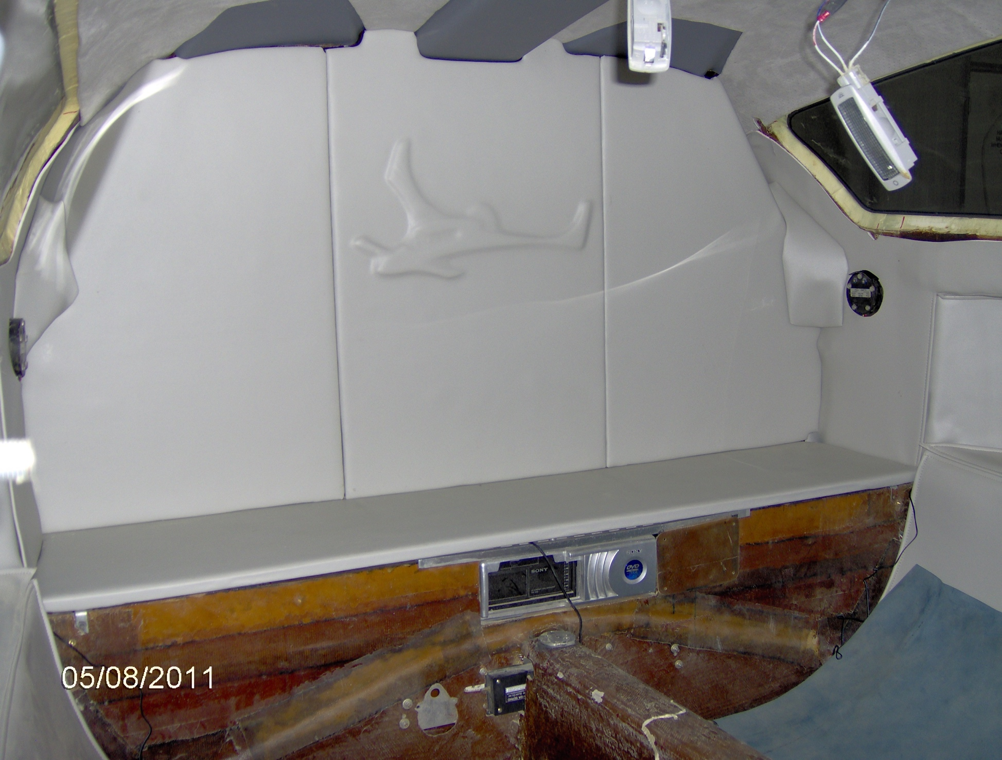  Upholstery by Dave Spano

@ Oshkosh Airventure 2014 – EZ Street

